Ideation Phase

Brainstorming & Idea Prioritization Template

Date | 28 September 2026
Team ID | SWTID-2026-8620
Project Mark | Import Data using Transform Maps (Spreadsheet)
Maximum Mark | 4 Marks

Brainstorm & Idea Prioritization Process

Brainstorming provides a free and open environment, that encourages everyone within a team to participate in the creative thinking process that leads to problem solving.
Prioritizing volume over value, out-of-the-box ideas are welcome and built upon, and all participants are encouraged to collaborate

Team Gathering, Collaboration and Select the Problem Statement
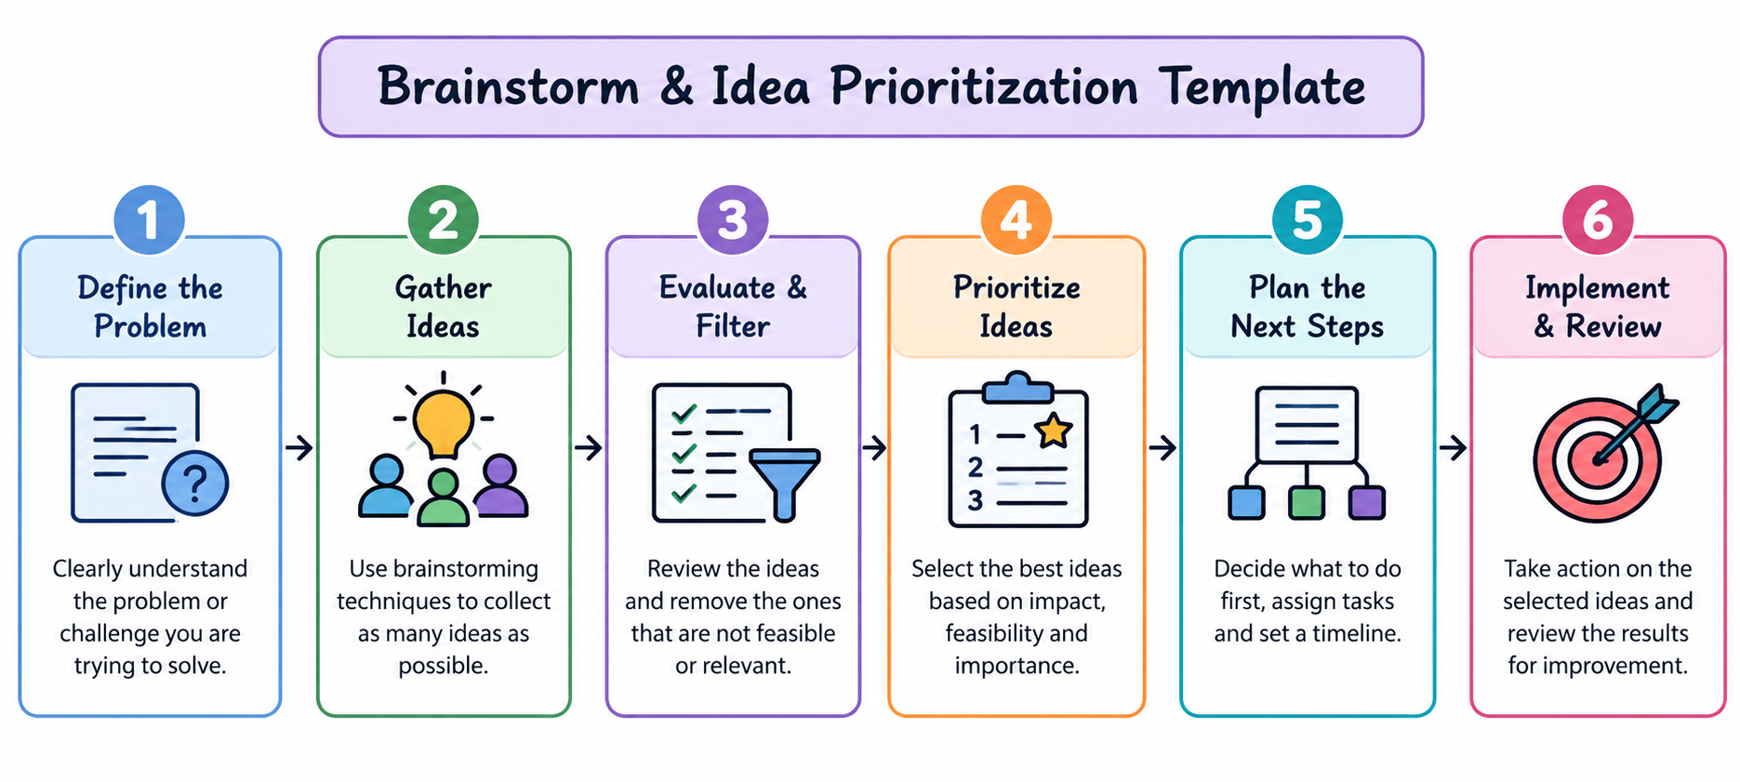

Step 1 : Define the Problem
Clearly identify the problem, the people affected, the current difficulty and the expected result. Write the problem in one simple and specific statement.
Step 2: Gather Ideas
Invite all team members to suggest ideas through brainstorming, discussion, observation and mind mapping. Encourage creative ideas and do not reject suggestions too early.
Step 3: Evaluate & Filter
Review the ideas and remove duplicate, irrelevant or unrealistic suggestions. Check usefulness, feasibility, available resources, time and possible risks.
Step 4: Prioritize Ideas
Compare the shortlisted ideas using impact, feasibility, urgency, cost and importance. Select the ideas that can create useful results and can realistically be implemented.
Step 5: Plan the Next Steps
Prepare an action plan. Decide what has to be done, who is responsible, what resources are required and when each activity should be completed.
Step 6: Implement & Review
Implement the selected idea, monitor progress and collect feedback. Check whether the original problem is solved and improve the solution when necessary.

Team Brainstorming Guidelines
- Understand the problem before suggesting solutions.
- Give every team member an opportunity to participate.
- Listen to ideas without immediate criticism.
- Build on useful ideas suggested by others.
- Group similar ideas and remove duplicates.
- Evaluate ideas using clear and fair criteria.
- Select ideas based on impact and feasibility.
- Assign responsibilities and set a timeline.
- Record decisions and expected outcomes.
- Review the result and improve it using feedback.
Sample Problem Statement
Users may face difficulty in reporting, tracking and resolving service requests because the existing process may involve delays, unclear communication and limited visibility of request status. A simple and organized service process is therefore needed.
Expected Outcome
The process should produce multiple ideas, identify practical solutions, create a clear action plan and support continuous improvement.

